Kettlebell 16 KG, Vinyl Coated Kettlebells, Make your kettlebell set to exercise at home or gym
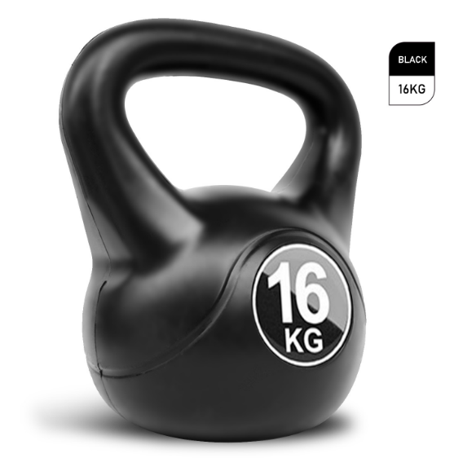

About this item
- BUILD YOUR BODY | Kettlebell is great for improving grip strength, flexibility and core stability. Excellent for working out arm, leg, back ab muscles.They can be used outdoor as well as indoors.
- MAKE YOUR HOME YOUR GYM | This kettlebell is not only suitable for gyms, but also suitable for exercise at home, very suitable for all kinds of people who like to exercise.
- QUALTY & DURABILITY | The Kettlebell weight inner is made of Concrete, which is more durable than other kettlebells.The vinyl coating is wrapped around it, which can protect the floor, reduce impact noise, is easy to clean.
- DESIGNED FOR COMFORT | The kettlebell is equipped with recessed grip handle and large handle that provides an ample amount of distance from the bell weight. These weights will provide maximum comfort and safety. The flat base design allows you to put it on any flat place at any time without worrying about rolling.
- CREATE YOUR OWN SET | We provide 4/6/8/10/12/14/16kg kettlebell, which are perfect for varying workouts. You can choose the weight depending on your body strength and requirements.

Technical Details
Size | ‎16 KG
Material type | ‎Vinyl
Brand | ‎LMS Data
Manufacturer | ‎LMS Data
Manufacturer reference | ‎KET-WGT-BELL-16
ASIN | ‎B09BNVXTG9

Warranty & Support
Amazon.com Return Policy:Regardless of your statutory right of withdrawal, you enjoy a 30-day right of return for many products. For exceptions and conditions, see Return details.

